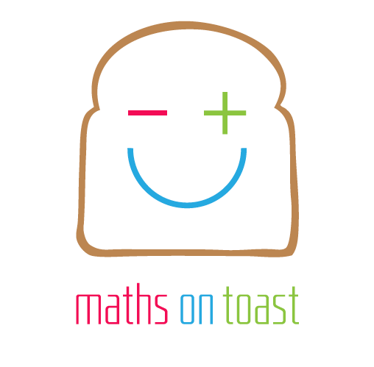
Maths on Toast

Theory of Change

Our impact
As a result of our activities, we want to see, in the country as a whole:
- More positive attitudes towards maths
- Increased confidence and resilience in doing maths
- Broadened awareness of what and where maths is
- Maths perceived, and carried out, as a human, social activity
All of these are precursors to increasing and broadening attainment in mathematics.

Our outcomes
Individuals participating in our activities will:
- Enjoy doing maths together, and be aware it is maths they are enjoying
- Increase their confidence in maths – see it as something they can do
- Engage in mathematical activities, showing concentration, play, and perseverance
- Broaden their view of what maths is
- Be supportive of others’ mathematical learning
- Interact with a broad section of the community and become more aware of the opportunities maths opens up to them
- Increase their enthusiasm for maths, reduce any fear of it – and do more, afterwards

Our beneficiaries
We work with families, parents and children together.

June 2014

