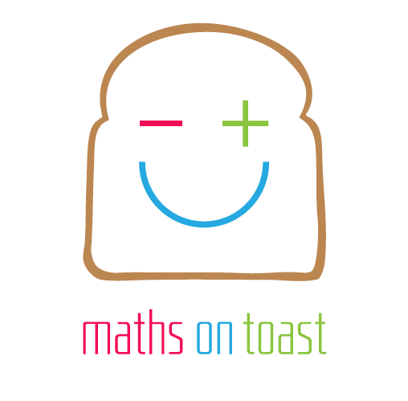October 2021

Job description
Community and Schools Outreach Practitioner
Initial fixed term contract to end of September 2022. This is the current funding period; we aim to continue the post after this period with alternative funding
2 days per week (14 hours). May be increased at a later date if applicant interested/funding allows
Salary: £25,000 - £31,000 pro rata depending on relevant skills and experience
Location: London. Office base in Hoxton; outreach/delivery across various London boroughs.
Flexible working hours: This role will require some weekend working as standard (minimum of 2 Saturdays per month). Outside of outreach/delivery, mix of work from home and office-based working. You will need to ensure your time in the office overlaps with other staff, we currently have a core set day.
Reports to CEO
Introduction
Maths on Toast - the family maths charity - is here to make every family feel empowered and inspired about maths by showing that maths can be a creative, enjoyable family activity.
Our ambition is to build Maths on Toast’s reach, making it the go-to organisation for fun family maths that is accessible to all – challenging perceptions of what maths is and transforming children’s and parents’ experience of doing maths together.
Our target audience is families with children between 5 and 12 years old.
We run events and workshops in the community, including in libraries; develop resources for use at home; and work with schools to reach more families and encourage parental involvement in creative maths. We work with targeted community groups to reach people who might not otherwise come to us.
The role
Are you a creative learning expert, enthusiastic and with experience of working with children and families within the community or a passionate teacher?
Do you believe that maths is a broad, varied and creative subject and that everyone should be able to feel good about maths?
Can you help us show families how to explore and enjoy creative maths?
If you are interested in a role that combines delivery and development of hands-on family maths learning workshops, events, training programmes and creative maths resources; networking to grow the organisation’s reach; and monitoring the impact of your work, get in touch now!
Who we are looking for
This is a fantastic opportunity for someone keen to take an active role in a small, ambitious charity that is growing year on year.
Your mission: to make maths fun for all the family! You will be responsible for the collaborative generation of ideas, development of workshops, resources, and programmes. Your chief focus will be the hands-on delivery of our creative, family-friendly maths resources, workshops and partnership programmes to wide and diverse local communities
1. Delivery, project management and publicity, monitoring and evaluation
- To deliver family maths events in libraries, community settings and schools, providing a welcoming and stimulating learning environment and support for newcomers and regular attendees alike
- To plan a rolling programme of events, workshops and programmes in community and school settings including targeting hard-to-reach groups
- To contribute to the development and delivery of training programmes to ‘cascade’ our ethos and knowledge and grow our reach
- To recruit, support and train a team of volunteers to support our regular family maths events, including complying with our Safeguarding policy
- To make sure events are well marketed to a diverse audience, both online and offline, building on our existing marketing strategy and in co-ordination with delivery partners
- To communicate, in an audience-appropriate way, our creative maths ethos and resilience mindset in person; to help develop strong messaging that ‘speaks’ to our intended audiences across digital and print content/output
- To develop and administer monitoring and evaluation processes to assess the impact of our work, including consulting with community partners to develop effective and collaborative processes
- To ensure clear and consistent recording of information and data enabling the effective and timely submission of reports to funders as required and regular reports to the board of trustees
- Management of project budget and spending

2. Content development and pedagogy
- To commit to reflective and responsive principles of practice, listening to the challenges of community partners and developing strategies to help address needs and challenges
- To keep up to date on ideas about maths teaching, and barriers to maths learning, and draw inspiration from a range of sources for the collaborative development of activities
- To generate ideas and contribute to the development of content which supports our aims of giving families fun, positive, creative, social, human experiences of maths and draws on the ‘Toast Model’ of resilience and growth mindset principles.
- With the assistance of the CEO, to ensure all content is mathematically accurate.
- To work with the CEO and team to broaden our offer and devise new programmes and projects

3. Networking, relationship building and maximising opportunities
- To build contacts and develop relationships across the community sector for partnership working and to maintain relationships with existing partners, including libraries, schools and community organisations
- To maintain and build partnerships with other relevant stakeholders
- To increase our contacts through existing networks
- To identify opportunities and networks for development of new partnerships for future collaboration
- To share ideas and best practise of how organisations can work together to meet their various aims and empower their beneficiaries
- To input into new fundraising applications as requested, contributing ideas and thinking through practicalities
- To keep an eye out for opportunities to increase the reach of our programmes and the distribution of our products, including Festival of Triangles and Number Rumbler
- To be pro-active in looking for any potential for partnership working and ways to grow our reach
You may be asked to take on any other tasks that may reasonably arise in line with your role and the organisational needs of our small team.
Person specification
We recognise demonstrable and proven experience as an asset and where appropriate, will value this as equal to formal qualifications.
Applicants need to fulfil one of the following two categories:
- Proven family/community practitioner with experience in developing and delivering workshops in informal learning environments, combined with a special interest or formal qualification in maths
- Proven teacher, preferably with experience in parental engagement
Essential:
- A passion for maths in its many and varied forms
- Proven experience of child-led learning
- Strong communication skills; able to talk to people from a wide range of backgrounds
- Familiar with community learning and education, outreach and delivery
- Understanding of the needs of family and primary school age audiences
- Experience of building relationships with families and/or communities
- Ability to communicate the value of family/community learning opportunities
- Ability to manage projects
- Enthusiasm for the vision and mission of the charity
- Self-starter, with a proven ability to work on your own initiative
- Relationship builder: keen to collaborate and build networks
- Organised: excellent administration and organisational skills
- Team worker: happy to pitch in
Desirable:
- Experience of informal learning contexts
- Understanding/experience of the needs of families in challenging circumstances
- Understanding/experience of working with hard-to-reach community groups
- Experience of managing volunteers
Because we work with children, and as our office is located in a community college, you will be required to undergo a DBS check.
What we can offer you
- Flexible working days/times
- Pro rata equivalent of 25 days holiday plus bank holidays
- NEST Pension
- The opportunity to work with a committed, friendly team in a small charity
How to apply
Please email Lucy Davis, CEO – lucy@mathsontoast.org.uk - if you would like to arrange an initial phone call about the role, or have any questions.
Please apply by sending a CV and a letter (max. 2 sides A4) explaining your motivation and relevant experience to info@mathsontoast.org.uk

Deadline for applications: 6pm, 19th November 2021
Interviews will be held via Zoom or in person at our office (tbc) w/c 29th November.

